LS Attendance
Additional Application Requirements
Worker mobile attendance with GPS and photo · supervisor and admin workflow · Azure hosting
Item | Value
Organisation | Latinem Securities L.L.C. (Sobha Group)
Applications | Attendance Tracker (admin) · Worker Attendance (phone)
Document version | 1.0
Date | 30 September 2026
Status | For review
Attachments | LS Attendance - Azure Resource Requirements.xlsx · architecture.png

1. Purpose and scope
The Attendance Tracker already produces the payroll attendance, the client timesheets (LS/DO/F-026) and the tax invoice pack from Excel data entered by the admin. This document adds a second mode: workers mark their own attendance on a phone, with the location and an on-site photo stored as proof. Their attendance is marked automatically in the admin tracker.
In scope: worker check-in / check-out with GPS and photo, geofenced site locations with maps, supervisor site board and decisions for days without a check-in, admin sync, review and punch details, Azure hosting with access levels.
Out of scope (decision 30 Sep 2026): leave requests raised by workers. When there is no check-in, the supervisor or admin decides what the day is (absent, day off, sick leave, annual leave and so on).

2. Users and access levels
Role | Who | Sign-in | Can do
worker | About 900 guards, CCTV operators, team leaders | Emp ID (remembered) + 4-digit PIN | Own check-in / check-out, own month
supervisor | Site supervisors | Microsoft Entra ID (Sobha account) | Site board, punch on behalf, decide no-check-in days
admin | Attendance owner (Ali) | Microsoft Entra ID | Everything in the tracker: sites and zones, PINs, publish, review, decisions, timesheets, invoices
viewer | Accounts | Microsoft Entra ID | Read-only: tracker, punches, photos

3. Functional requirements
ID | Requirement | Priority | Acceptance
FR-W01 | Sign in with Employee ID and a 4-digit PIN. The Employee ID is remembered on the phone ("remember me"); the PIN is typed every time. "Not you?" clears it. | Must | Second visit shows the saved ID and the PIN pad only.
FR-W02 | CHECK IN and CHECK OUT buttons, one pair per shift. Hours worked are shown after check-out. | Must | Check-out pairs with the open check-in; hours = difference.
FR-W03 | The phone location (latitude, longitude, accuracy) is captured at the moment the button is pressed and stored with the punch. | Must | Punch record holds lat, lng, ±accuracy; no background tracking.
FR-W04 | An on-site photo is taken with the front camera for every punch (gallery not offered). Name, Emp ID, date-time, coordinates and site are burned into the photo. | Must | Photo stored privately; watermark visible in Punch details.
FR-W05 | Live status on the home screen: map with own position, accuracy circle and site zone; chip "In zone · 42 m from INFRA OFFICE". | Should | Chip turns green inside a zone.
FR-W06 | Offline: with no signal the punch (time, GPS, photo) is saved on the phone and sent automatically when back online. | Must | Queued punch keeps its original time; flagged "offline".
FR-W07 | "My month" calendar of the worker's own P / A / OFF / leave codes and days worked. | Should | Matches the tracker after Publish roster.
FR-W08 | Languages: English, Hindi, Urdu (right-to-left), Malayalam. | Should | Switch from the header; choice remembered.
FR-W09 | One phone per worker; 5 wrong PINs lock the ID for 15 minutes. | Must | Other phone refused until admin resets the device.
FR-S01 | Supervisor site board: every app worker of a site with state – in, done, no check-in, marked. | Must | Counts per state for the chosen date.
FR-S02 | Supervisor can check a worker in or out on his behalf (photo still required), e.g. a dead phone. | Should | Punch shows "by supervisor: <name>".
FR-S03 | No check-in: the supervisor decides what the day is – A, OFF, SL, AL, EL, UL, SIRA, or P (present without phone) – for today or a past date. | Must | Decision reaches the tracker on the next sync.
FR-A01 | Site locations: search a place with suggestions while typing, Map / Satellite views, click or drag the pin, several pins per site, zone radius slider, paste coordinates or a Google Maps link. | Must | Pins and radius saved on the site; overview map of all zones.
FR-A02 | Publish roster: workers with app access, their site and shift, PIN hashes, site zones and rules are sent to the worker app. | Must | Phones use the new data at next sign-in / refresh.
FR-A03 | App access: enable workers, generate PINs (shown once), print PIN slips with QR link, reset phone, disable. | Must | Only the PIN hash is stored.
FR-A04 | Sync every 5 minutes (and on demand): accepted check-ins become P, or R with the site for a reliever; supervisor decisions become their code. | Must | Grid shows a dot on app days.
FR-A05 | Review list for pending punches (outside zone, poor GPS, clock) with Approve / Reject and reason. | Must | Approve → P; reject → day cleared, reason kept.
FR-A06 | Right-click a day in Attendance → Punch details: times, hours, coordinates, accuracy, distance to pin, zone status, both photos, satellite map, approve / reject. | Must | Opens from the context menu of any day.
FR-A07 | No check-in list per date: app workers allocated to a site with no check-in and no code; admin marks them one by one or in bulk. | Must | List empties as days are decided.
FR-A08 | Data checks include punches to review, no check-in, sites of app workers without a location, conflicts. | Should | Counts in the check pill on Attendance.
FR-A09 | Locked payroll months are never changed by sync, review or decisions. | Must | Message shown instead.
FR-A10 | Existing functions unchanged: Excel import, client timesheets (LS/DO/F-026), invoice and break-up pack, Excel / PDF export. | Must | Regression tests pass; Elwood pack prints 7 pages.

4. Business rules
Rule | Definition
Zone rule | Accepted when (distance to nearest pin − GPS accuracy) ≤ zone radius AND accuracy ≤ 50 m (admin-set). Otherwise saved as Pending review – never lost.
Zone size | Circle around a pin, default 100 m, typical 30–500 m. 1 m² is not practical: phone GPS is accurate to about 5–30 m, worse indoors.
Reliever | Check-in inside another site's zone is accepted as a reliever (R at that site).
Check-in window | Opens 60 min before shift start (Day 07:00, Night 19:00, admin-set). Earlier = pending. Later than 15 min = "late" flag.
Night shift | Check-in in the evening and check-out next morning count for the check-in date.
Duplicates | A second check-in (or check-out) within 30 min is refused. Resent offline punches are recognised and not doubled.
Precedence | A code typed in the tracker is kept over the app (listed as a conflict). An accepted app check-in wins over a supervisor mark. A supervisor mark can be changed or cleared until the month is locked.
Leave | Workers do not request leave in the app. Leave and absence are decided by the supervisor (phone) or admin (tracker) for days with no check-in.

Day codes when there is no check-in
A – Absent · OFF – Day off · SL – Sick leave · AL – Annual leave · EL – Emergency leave · UL – Unpaid leave · SIRA – SIRA exam / training · P – Present, no phone (supervisor confirms). The codes and their billable flags are those already defined in the tracker (Settings → Attendance codes).

5. Non-functional requirements
Area | Requirement
Availability | Azure Static Web Apps Standard (SLA 99.95%). Punches queue on the phone during outages.
Performance | Check-in round trip under 3 s on 4G excluding photo upload; admin sync of one day (≈1,800 punches) under 10 s.
Capacity | 900 workers × 2 punches × 30 days ≈ 54,000 punches and ≈ 8 GB photos per month; ≈ 95 GB photos at 12-month retention.
Security | HTTPS only; Entra ID for staff; role routes in staticwebapp.config.json and checks in the API; PINs hashed with PBKDF2-SHA256 (100k rounds, per-worker salt); HMAC-signed 20-hour worker sessions; private photo container; content security policy; no secrets in the pages.
Privacy | UAE Federal Decree-Law No. 45 of 2021 (Personal Data Protection): location read only when a button is pressed; photos used only as attendance proof; retention 12 months (lifecycle rule); access limited to admin, supervisor and viewer roles.
Audit | Each punch keeps device time, server time, device ID, who punched (worker / supervisor), reviewer and reason; each day mark keeps who decided and when.
Backup | Blob soft delete (7 days); admin tracker data kept in the browser with JSON backup to LS_Documents; optional scheduled export of tables.
Usability | Large buttons, four languages, works on low-end Android; admin grid shows 28+ days on a laptop.

6. Architecture
One Azure Static Web App hosts both pages and a managed Azure Functions API. One storage account holds workers, sites, punches and day marks (Table Storage) and photos (private Blob container). Staff sign in with Microsoft Entra ID; workers use a PIN. Maps and search are called from the browser.
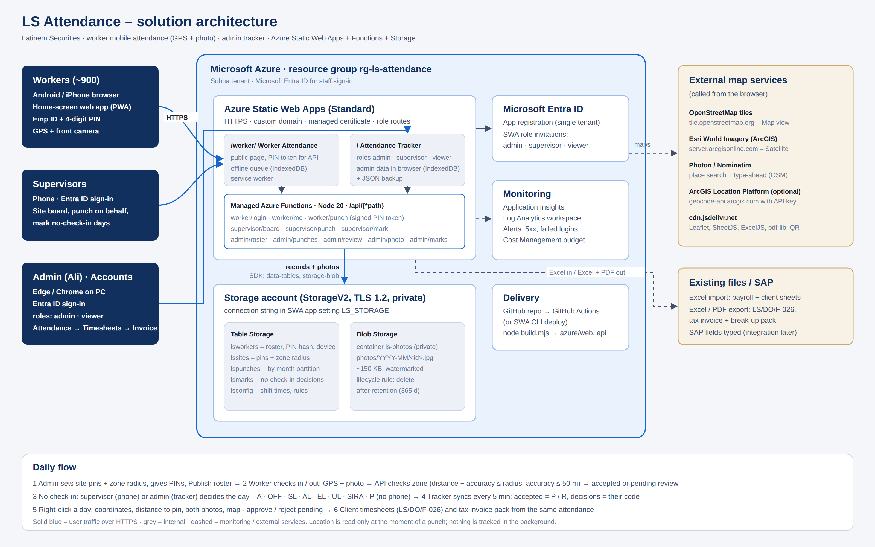
Figure 1 – Solution architecture (full size: docs/architecture.png / .svg)

API endpoints
Endpoint | Role | Purpose
POST /api/worker/login | anonymous | Emp ID + PIN + device → 20-hour token and profile
GET /api/worker/me | worker token | Profile, site zones, today's punches, month codes
POST /api/worker/punch | worker token | Check-in / out with GPS and photo → zone check → accepted or pending
GET /api/supervisor/board | supervisor | Workers of a site and date with punches and marks
POST /api/supervisor/punch | supervisor | Punch on behalf of a worker (photo required)
POST /api/supervisor/mark | supervisor | Decide a no-check-in day (code or clear)
PUT /api/admin/roster | admin | Publish workers, PIN hashes, sites, zones, rules
GET /api/admin/punches · /marks | admin, supervisor, viewer | Incremental pull since last sync
POST /api/admin/review | admin | Approve / reject a pending punch
GET /api/admin/photo | admin, supervisor, viewer | Stream one photo

Data model
Store | Fields
lsworkers | id, code (Emp ID), name, trade, shift, siteId, enabled, pinHash, pinSalt, deviceId, fails, lockUntil, months (codes for My month)
lssites | id, name, project, pins [lat, lng, radius, label]
lspunches | id, wid, code, name, type in/out, ts, serverTs, workDate, lat, lng, acc, siteId, dist, radius, inZone, reliever, status, reasons, flags, photo path, clientId, deviceId, by, inId/outId, hours, reviewBy, reviewNote
lsmarks | id (worker|date), wid, code, date, mark (A/OFF/SL/…), note, by, at, prev
lsconfig | radius, maxAcc, windowMin, lateMin, photo, bindDevice, shift starts, shiftHours
ls-photos (blob) | photos/YYYY-MM/<punch id>.jpg – watermarked JPEG ≈150 KB

7. Application runtime stack and versions
Layer | Component | Version
Hosting | Azure Static Web Apps | Standard
API runtime | Azure Functions host (managed by SWA) | 4.x
API language | Node.js | 20 LTS
API packages | @azure/functions · @azure/data-tables · @azure/storage-blob | ^4.5.0 · ^13.2.2 · ^12.24.0
Data | Azure Table Storage + Blob Storage (StorageV2) | TLS 1.2+
Security | WebCrypto PBKDF2-SHA256 / HMAC-SHA256 | built-in
Front end | HTML5 + vanilla JavaScript (ES2020), two single-file pages | n/a
Maps | Leaflet · OpenStreetMap tiles · Esri World Imagery · Photon / Nominatim | 1.9.4
Excel / PDF | SheetJS · ExcelJS · pdf-lib · qrcode-generator | 0.18.5 · 4.4.0 · 1.17.1 · 1.4.4
Browsers – admin | Microsoft Edge / Google Chrome | Chromium 110+
Browsers – worker | Chrome for Android / Safari on iOS | Android 9+ · iOS 16.4+
Build / test | Node.js · Playwright · Azurite | 20+ (tested 22.22) · 1.47+ · 3.x

8. Azure resources
Detailed in the attached spreadsheet, with sizing and indicative monthly cost formulas. Summary:
- Resource group rg-ls-attendance (UAE North).
- Azure Static Web Apps – Standard, with the managed Functions API (Node 20).
- Storage account StorageV2 (UAE North) – Table Storage and private Blob container ls-photos, lifecycle rule for photo retention.
- Microsoft Entra ID app registration (single tenant) and role invitations: admin, supervisor, viewer.
- Recommended: Application Insights with Log Analytics, custom domain, Cost Management budget, GitHub Actions deployment.
- Optional: Key Vault (only with a linked Functions app), ArcGIS Location Platform key.

9. Deployment and environments
Environment | How | Data
Demo | Open the two HTML files from LS_Documents | Kept in the browser only
Local test | node build.mjs && node azure/dev-server.mjs → http://localhost:4280 | azure/.dev-data-<port>.json
Production | Azure Static Web Apps; steps in azure/README-deploy.md | Azure Storage (UAE North)
Go-live steps: create resources → set LS_STORAGE and LS_TOKEN_SECRET → deploy → invite admin, supervisors, viewers → set site pins and zones → enable workers and print PIN slips → Publish roster → workers add the page to the Home screen.

10. Testing and acceptance
Suite | Result | Covers
API rules (in-memory) | 28 / 28 | Lock-out, device binding, zone in/edge/outside, accuracy, reliever, night shift, duplicates, offline resend, review, photos, day marks, roles
Azure store (Azurite emulator) | 9 / 9 | Real Table/Blob adapter: filters, partitions, pairing, photo round-trip
Functions HTTP wrapper | 4 / 4 | Role header from Static Web Apps, JSON, 403s
End-to-end (file and HTTP) | 16 / 16 | Site map search → PINs → publish → phone check-in (fake GPS + camera) → outside-zone review → supervisor mark → sync → right-click details → approve → admin no-check-in decision
Phone extras | 5 / 5 | Offline queue and resend, Urdu right-to-left, supervisor board
Regression | all pass | Existing tracker suites 17 + 4 + 5, CTS import 104/104 projects, Elwood pack 7 pages
User acceptance: one pilot site for one payroll month; compare app attendance with the supervisor's sheet day by day before rolling out to all sites.

11. Assumptions and open items
- Number of supervisors and viewers (role invitations are limited to 25 users per role; beyond that map Entra ID groups to roles).
- Photo retention period (12 months proposed) and who may view photos.
- A worker privacy notice to show once at first sign-in (wording from Legal / HR) – to be added before go-live.
- Custom domain, for example attendance.latinem.ae, and DNS owner.
- Native-speaker check of the Hindi, Urdu and Malayalam texts.
- Location pins and radius for every site in use (the tracker lists sites without one).
- Whether Esri / ArcGIS terms need a paid key for production volume.
- Phase 2: move the admin tracker data (attendance, rates, invoices) to Azure so several admins can work at once; SAP integration for the invoice fields.

